**A PROJECT REPORT**

**ON**

**SMART ATM SECURITY SYSTEM USING PIC 18f4520**

SUBMITTED TO THE SAVITRIBAI PHULE UNIVERSITY OF PUNE

IN THE PARTIAL FULFILLMENT FOR THE AWARD OF THE DEGREE

**OF**

**THIRD YEAR OF ENGINEERING (SEM-2)**

**IN**

**ELECTRONICS AND TELECOMMUNICATION**

**BY**

|  |  |
| --- | --- |
| **TANVI MANE** | **EXAM NO:71821090F** |
| **ARCHANA LONKAR** | **EXAM NO:71821041H** |
| **RUTUJA LAIGUDE** | **EXAM NO:71821020E** |

**UNDER THE GUIDANCE OF**

**Prof. Mrs. VIJAYA YADUVANSHI**



**DEPARTMENT OF ELECTRONICS AND TELECOMMUNICATION ENGG.**

**STES’S**

**SMT.KASHIBAI NAVALE COLLEGE OF ENGINEERING**

**VADGAON BK., OFF.SINHAGAD ROAD**

**PUNE – 411041**

**2019-2020**



**CERTIFICATE**

This is to certify that the project title entitled by

**“SMART ATM SECURITY SYSTEM USING PIC18f4520”**

Submitted by

|  |  |
| --- | --- |
| **TANVI MANE** | **EXAM NO:71821090F** |
| **ARCHANA LONKAR** | **EXAM NO:71821041H** |
| **RUTUJA LAIGUDE** | **EXAM NO:71821020E** |

is a bona fide work carried out by them under the supervision of Prof. Mrs. VIJAYA YADUVANSHI and it is approved for the partial fulfillment of the requirement of the University of Pune for the award of the Third year of Bachelor of Engineering (Electronics and Telecommunication).

This mini project and seminar report have not been submitted to any other Institute or University for the award of any degree or diploma.

|  |  |  |
| --- | --- | --- |
| **Prof.Mrs.VijayaYaduvanshi**  Guide  Department of E&TC | **Dr.Prof.Mrs.S.K.Jagtap**  Head  Of Department of E&TC | **Dr.Prof.A.V.Kulkarni**  Principal  Of S.K.N.C.O.E Pune-41 |

Place: Pune

Date:

**ACKNOWLEDGEMENT**

We are grateful to **Smt. Kashibai Navale College of Engineering, Pune** for giving us an opportunity to develop this project with esteemed organization. The volume of the work would not have been possible without contribution in one form or the other by few names to mention.

We feel great pleasure in submitting this project report on “Smart ATM Security system using PIC 18f4520”. We wish to express true sense of gratitude towards our project guide **Prof. Mrs. VIJAYA YADUVANSHI** who at very discrete step in study of this project contributed her valuable guidance to solve every problem that arose.

We express our sincere thanks to honorable Principal, Smt. Kashibai Navale College of Engineering, Pune **Dr. Prof. A. V. DESHPANDE**, for supporting us.

We wish to thank **Dr. Prof. S. K. JAGTAP** head of Department, Electronics and Telecommunication, Smt. Kashibai Navale College of Engineering, Pune for opening the doors of department towards the realization of the project.

**TANVI MANE**

**ARCHANA LONKAR**

**RUTUJA LAIGUDE**

**ABSTRACT**

In the era of digitalization, everyone needs money without interaction with bank at any time. As the reliance on ATMs have increased, prevention of theft and security of customers is the prime objective. This paper gives the description of the new approach towards security of ATM (Automated Teller Machine) system and the objective of the paper is to know the enhanced smart ATM security system which is developed using PIC microcontroller. The proposed paper would be highly beneficial to provide protection against frauds. In this paper the security approaches of ATM have been improved using GSM module, vibration sensor, limit switch, DC motor and other advanced technologies.

***Keywords*** -ATM security, PIC microcontroller, GSM module, DC motor, vibration sensor.

**LIST OF TABLES**

|  |  |  |
| --- | --- | --- |
| TABLE NO. | TITLE | PAGE NO. |
| 3.3.4 | PARAMETRIC OF PIC 18F4520 | 15 |
| 3.6.2 | PIN DESCRIPTION OF L293D | 21 |
|  | APPENDIX | 31 |

**LIST OF FIGURES**

|  |  |  |
| --- | --- | --- |
| FIG. NO. | TITLE | PAGE NO. |
| 3.1 | BLOCK DIAGRAM | 13 |
| 3.2 | PIN DIAGRAM OF PIC 18F4520 | 14 |
| 3.3 | PINOUT OF VIBRATION SENSOR SW-420 | 16 |
| 3.4.1 | GSM MODULE (SIM900A) | 17 |
| 3.4.2 | GSM MODULE (SIM900A) PINOUT | 18 |
| 3.5 | INTERFACING OF L293D | 20 |
| 3.6 | LIMIT SWITCH | 23 |
| 3.7 | BUZZER | 24 |
|  |  |  |

**CONTENTS**

|  |  |
| --- | --- |
| **CERTIFICATE** | **I** |
| **ACKNOWLEDGEMENT** | **II** |
| **ABSTRACT** | **III** |
| **LIST OF TABLES** | **IV** |
| **LIST OF FIGURES** | **V** |

|  |  |  |  |  |
| --- | --- | --- | --- | --- |
| CHAPTER | | | TITLE | PAGE |
| 1 |  |  | INTRODUCTION | 9 |
|  | 1.1 |  | BACKGROUND | 9 |
|  | 1.2 |  | RELEVANCE | 9 |
|  | 1.3 |  | OBJECTIVE | 10 |
|  |  |  |  |  |
| 2 |  |  | LITERATURE SURVEY | 11 |
|  | 2.1 |  | INTRODUCTION | 11 |
|  | 2.2 |  | HISTORY | 12 |
|  | 2.3 |  | DRAWBACKS | 12 |
|  | 2.4 |  | OVERCOMES | 12 |
|  |  |  |  |  |
| 3 |  |  | DESIGN AND DRAWING | 13 |
|  | 3.1 |  | INTRODUCTION | 14 |
|  | 3.2 |  | BLOCK DIAGRAM | 14 |
|  | 3.3 |  | COMPONENTS | 16 |
|  |  | 3.3.1 | PIN DIADRAM |  |
|  |  | 3.3.2 | FEATURES OF PIC |  |
|  |  | 3.3.3 | ADDITIONAL FEATURES OF PIC |  |
|  |  | 3.3.4 | PARAMETRIC OF PIC |  |
|  | 3.4 |  | VIBRATION SENSOR | 17 |
|  |  | 3.4.1 | VIBRATION SENSOR PINOUT |  |
|  |  | 3.4.2 | FEATURES OF SW -420 | 17 |
|  | 3.5 |  | GSM MODULE |  |
|  |  | 3.5.1 | GSM MODULE (SIM 900A) PINOUT |  |
|  |  | 3.5.2 | GSM MODULE (SIM 900A) FEATURES |  |
|  |  | 3.5.3 | APPLICATIONS |  |
|  | 3.6 |  | DC MOTOR AND MOTOR CONTROLLER | 20 |
|  |  | 3.6.1 | INTERFACING WITH L293D |  |
|  |  | 3.6.2 | L293D PIN CONFIGURATION |  |
|  |  | 3.6. | FEATURES |  |
|  | 3.7 |  | LIMIT SWITCH | 22 |
|  |  | 3.71 | LIMIT SWITCH LAYOUT AND PIN CONFIGURATION |  |
|  |  | 3.7.2 | ADVANTAGES |  |
|  | 3.8 |  | BUZZER | 23 |
|  |  | 3.81 | BUZZER LAYOUT |  |
|  | 3.9 |  | EMBEDDED C LANGUAGE | 24 |
|  |  | 3.9.1 | FLOW CHART |  |
|  |  | 3.9.2 | MPLAB FOR SOURCE CODE |  |
|  |  | 3.9.4 | EXTREME PIC BURNER |  |
|  |  | 3.9.5 | PROTEUS FOR SIMULATION |  |
|  |  | 3.9.6 | SUMMARY |  |
|  |  |  |  |  |
| 4 |  |  | ADVANTAGES AND APPLICATIONS | 28 |
|  | 4.1 |  | ADVANTAGES |  |
|  | 4.2 |  | APPLICATIONS |  |
|  |  |  |  |  |
| 5 |  |  | CONCLUSION | 29 |
|  | 5.1 |  | CONCLUSION |  |
|  |  |  |  |  |
|  | REFERENCE | | | 30 |
|  | APPENDIX | | | 31 |

**CHAPTER 1**

**INTRODUCTION**

* 1. **BACKGROUND**

Automated teller machines, also widely known as ATM machines are an essential public service lately. Foundation to the several public services is the fact that service users themselves are capable of operating the information equipment essential for utilizing the services. The information equipment must be accessible to any individual to render quality public services to every user equally. Hence, automated machines are required to incorporate universal design so as to enable every user to operate the equipment. Using an automated teller machine is among the most common tasks that involve an individual might adopt for a living. An ATM ais a computerized telecommunication device that offers the customers of financial companies access to performing financial transactions publicly in the absence of a human clerk or a bank teller. With ATMs, customers are able to access their bank accounts for making cash withdrawals, transferring money, and checking their account balance, as well as paying electronic bills. Even though ATMs are widespread and very convenient, however, study shows that older individuals and customers with disabilities face problems with their functioning. Some machines are available in areas such as gas stations, grocery stores, airports, and shopping malls. While they offer convenient options there are issues they face regularly including security and fraud.

* 1. **RELEVANCE**

As there is a risk of getting the ATM machine looted, almost all the counters have a security guard to ensure the safety of the money inside the machines. There are ATMs that feature security elements such as hidden cameras and security pin numbers to help people use them with fewer worries. Con artists have gone as far as creating external devices that attach onto a real ATM that helps collect personal data during a transaction. In recent years many ATM designs have been upgraded or changed to help reduce this risk. Some machines may warn customers about possible fraud and what to look for if they suspect it. Security issues continue to be improved and monitored as more people rely on ATMs on a regular basis. This project aims to address the issues related with looting and attachment of external devices to the ATM machine.

**1.3OBJECTIVE**

Following is the main objective and prime purpose of implementing this project – ATM security is the prime need of the day. Allotment of a security guard and hidden security cameras are important; however, they have certain disadvantages. In order to prevent loots and illegal attachment of devices, a system has been implemented which is known as “VIBRATION SENSOR BASED ATM SECURITYSYSTEM”. It uses a microcontroller and a vibration sensor that sets up a progression events that avert the theft from occurring. It also involves the development of a reliable system using a GSM module that assists the police force in maintaining law and order against crimes and ensure public safety.

**CHAPTER 2**

**LITERATURE SURVEY**

**2.1INTRODUCTION**

The main objective of this chapter is to focus on the concepts and theories those are used in this project. It consists of the system and its study that have been already designed. The chapter also includes the significant features of the system.

**2.2HISTORY**

Automated Teller Machines (ATM) offers much convenience to everyone in life due to their easy and readily available cash. Frauds related to the ATM are increasing day by day which is a serious issue. ATM is equipped with surveillance monitor criminals can usually break it down and robbery its wealth by occluding their faces. The attacks on ATMs are steadily rising and this is a serious problem for law enforcement and banking sectors. This paper is mainly focusing on protection of ATM machine using CCTV security cameras and emergency sirens. The ATM machines are not safe since security provided traditionally by using RFID or security guards outside the ATM. This security system can alarm automatically it will greatly improve financial security and acts as detective work of the police. There is variety of ATM attacks because it is such an attractive target. Basically there are various types of attacks like Physical attack, ATM fraud and Software attack. So this security system has to be developed and put in to place that will make sure the ATM is safeguarded and also gives customers the confidence when using the ATM. When MEMS sensor detects any movement of ATM; it sends signals to the LPC 2148 via GPIO pins. Someone tries to hit on the ATM Machine Force sensors senses the pressure. The applied force is greater than the threshold value, the above operation will be activated. The controller used here is the popular ATMEGA-328 from ATMEL. This system is built around the ATMEGA328 microcontroller which belongs to the ATMEL family. The system continuously monitors its surroundings by sensing temperature changes, force and orientation of the ATM using the sensors.

**2.3DRAWBACKS**

* This security is not efficient because RFID card can be stolen and can be misused for robbery.
* The watchmen can be blackmailed.
* The security alarm acts as detective work for police but it will take time for the police to reach the location and till then the robbers can escape.
* Though there are facilities of CCTV now a days still the

**2.4OVERCOMES**

* In this project we would be using GSM module which would send a SMS to the respected authorities immediately.
* Vibration sensor is used so in case of any vibration, the sensor will give the signal to the microcontroller and further to the DC motor and the shutter of the ATM would be closed without further ado.

**CHAPTER 3**

**DESIGN AND DRAWING**

**3.1 INTRODUCTION**

This chapter explains on how this project will be implemented and components used in the project, brief description of each component. It includes each process from the beginning until the end of this project. This chapter includes the project as well as the hardware module wise discussion as the input module and the output module.

**3.2BLOCK DIAGRAM**

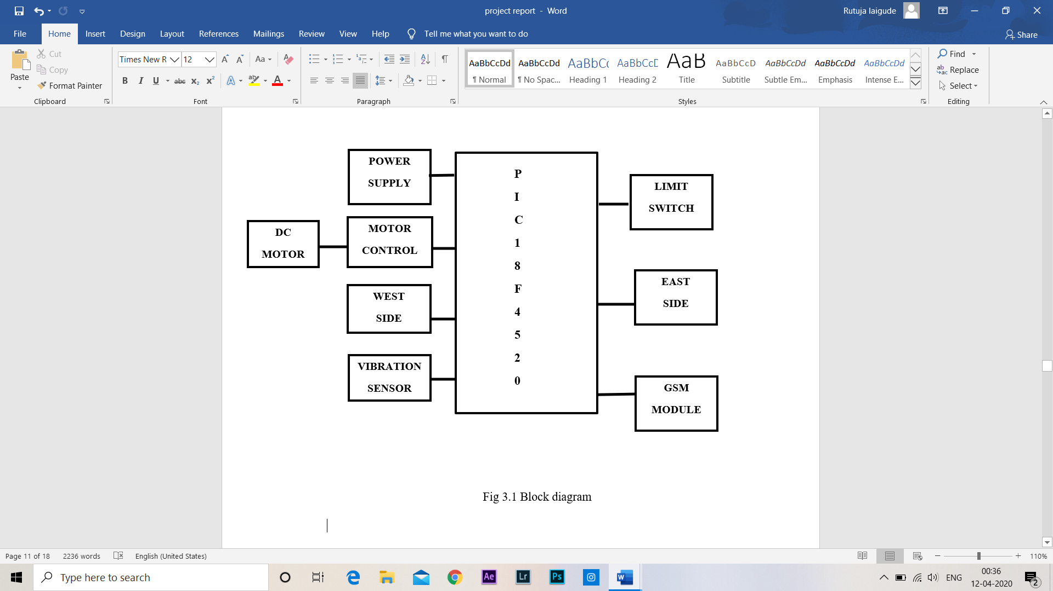

Fig 3.1 Block diagram

**3.3 COMPONENTS**

**3.3.1 PIC MICROCONTROLLER 18F4520**

The PIC18F452 is microcontroller with C compiler optimized architecture and Self Programmable under software control. It is cost effective and reliable. In the project the .hex file of the code is dumped in this controller.

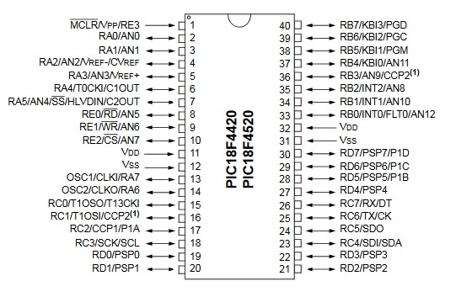

Fig 3.2 Pin Diagram of PIC18 microcontroller

**3.3.2 FEATURES OF PIC18 MICROCONTROLLER**

This powerful 10 MIPS (100 nanosecond instruction execution) yet easy to program (only 77 single word instructions) CMOS FLASH based bit microcontroller packs Microchip’s powerful PIC architecture into a 40pin package. The PIC18F452 features a ‘C’ compiler friendly development environment, 256 bytes of EEPROM, Self-programming, an ICD, 2 capture/compare/PWM functions, 8 channels of 10- bit Analog to Digital (A/D) converter, the synchronous serial port can be configured as either 3-wire Serial Peripheral Interface(SPI) or the 2-wire Inter-Integrated Circuit(I2C) bus and Addressable Universal Asynchronous Receiver Transmitter (AUSART). All of these features make it ideal for manufacturing equipment, instrumentation and monitoring data acquisition, power conditioning, environmental monitoring, telecom and consumer audio/video applications.

**3.3.3ADDITIONAL FEATURES OF PIC18 MICROCONTROLLER**

• PWM 10-Bit

• 40 MHz Maximum Speed

• Self-Programming

• PSP

• ICD

**3.3.4 PARAMETRIC OF PIC18 MICROCONTROLLER**

|  |  |
| --- | --- |
| **Name** | **Value** |
| Program Memory Type | Flash |
| Program Memory Size (KB) | 32 |
| CPU Speed (MIPS/DMIPS) | 10 |
| SRAM Bytes | 1536 |
| Data EEPROM/HEF (bytes) | 256 |
| Digital Communication Peripherals | 1-UART, 1-SPI, 1-I2C1-MSSP(SPI/I2C) |
| Capture/Compare/PWM Peripherals | 2 CCP |
| Timers | 1 x 8-bit, 3x 16-bit |
| ADC Input | 8 ch, 10-bit |
| Temperature Range (C) | -40 to 125 |
| Operating Voltage Range (V) | 2 to 5.5 |
| Pin Count | 40 |

**3.4 VIBRATION SENSOR (SW-420)**

Vibration Sensor that used in this project is SW 420 which has 3 pins to interface with microcontroller. The Vibration Switch SW – 420 is based on the vibration sensor SW – 420 and Comparator LM393 to detect if there is any vibration that beyond the threshold. The threshold can be adjusted by the on – board potentiometer. When there is no vibration, this module output logic LOW the signal indicates

LED light and vice versa.

**3.4.1VIBRATION SENSOR PINOUT:**

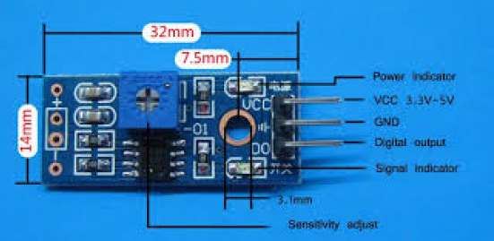

Fig 3.3 Pinout of Vibration Sensor SW-420

**3.4.2 FEATURES OF VIBRATION SENSOR MODULE SW-420:**

• Normally closed type vibration sensor SW 420.

• The comparator output, signal clean, good waveform, driving ability is strong, for more than 15 ma.

• The woring voltage of 3.3V to 5V.

• Output form: digital switch output (0 and 1).

• Has a fixe bolt hole, convenient installation.

• Small board PCB size: 3.2cm x 1.4cm.

• Use the LM393 wide voltage comparator.

**3.5GSM MODULE (SIM 900A)**

GSM Module used in this project is SIM 900A with microcontroller. The **SIM900A**is a readily available **GSM/GPRS module**, used in many mobile phones and PDA. The module can also be used for developing IOT (Internet of Things) and Embedded Applications. SIM900A is a dual-band GSM/GPRS engine that works on frequencies EGSM 900MHz and DCS 1800MHz. SIM900A features GPRS multi-slot class 10/ class 8 (optional) and supports the GPRS coding schemes CS-1, CS-2, CS-3 and CS-4. In this project we use GSM module to send message to nearest police station and respective bank

**3.5.1 SIM900A GSM MODULE PINOUT:**

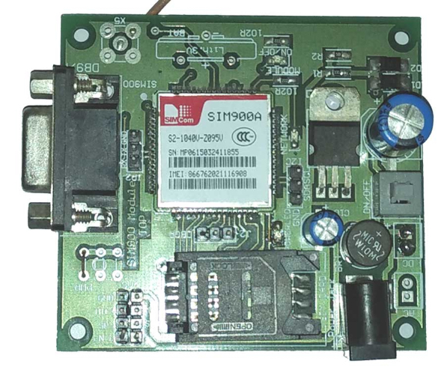

Fig.3.4.1GSM MODULE SIM900A

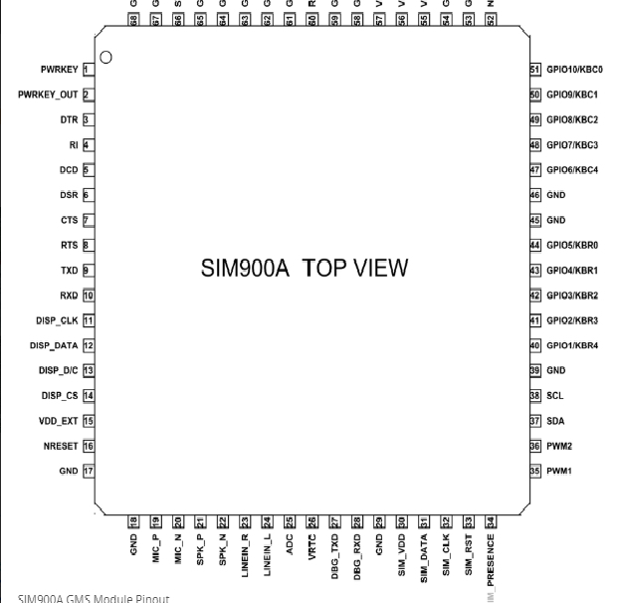

Fig 3.4.2 SIM900A Pinout

**3.5.2SIM900A GSM MODULE FEATURES**

• Single supply voltage: 3.4V – 4.5V

• Power saving mode: Typical power consumption in SLEEP mode is 1.5mA

• Frequency bands: SIM900A Dual-band: EGSM900, DCS1800. The SIM900A can search the two frequency bands automatically. The frequency bands also can be set by AT command.

• GSM class: Small MS

• GPRS connectivity: GPRS multi-slot class 10 (default) , GPRS multi-slot class 8 (option)

• Transmitting power: Class 4 (2W) at EGSM 900, Class 1 (1W) at DCS 1800

• Operating Temperature: -30ºC to +80ºC

• Storage Temperature: -5ºC to +90ºC

• DATA GPRS: download transfer max is 85.6KBps, Upload transfer max 42.8KBps

• Supports CSD, USSD, SMS, FAX

• Supports MIC and Audio Input

• Speaker Input

• Features keypad interface

• Features display interface

• Features Real Time Clock

• Supports UART interface

• Supports single SIM card

• Firmware upgrade by debug port

• Communication by using AT commands

**3.5.3 APPLICATIONS**

• Cellular Communication

• Robotics

• Mobile Phone Accessories

• Servers

• Computer Peripherals

• Automobile

• USB Dongles

**3.6 DC MOTOR AND MOTOR CONTROLLER**

Motor Controller l293d is used to controller normal DC motor. L293D IC is a typical Motor Driver IC which allows the DC motor to drive on any direction. This IC consists of 16-pins which are used to control a set of two DC motorsinstantaneously in any direction. It means, by using a L293D IC we can control two DC motors. As well, this IC can drive small and quiet big motors.

**3.6.1 INTERFACING OF L293D WITH DC MOTOR**

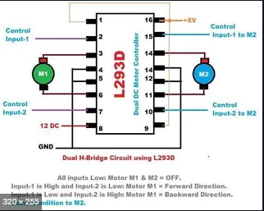

Fig.3.5 Interfacing of L293D

**3.6.2 PIN DESCRIPTION OF L293D**

|  |  |  |
| --- | --- | --- |
| **Pin**  **Number** | **Pin Name** | **Description** |
| 1 | Enable 1,2 | This pin enables the input pin Input 1(2) and Input 2(7) |
| 2 | Input 1 | Directly controls the Output 1 pin. Controlled by digital circuits |
| 3 | Output 1 | Connected to one end of Motor 1 |
| 4 | Ground | Ground pins are connected to ground of circuit (0V) |
| 5 | Ground | Ground pins are connected to ground of circuit (0V) |
| 6 | Output 2 | Connected to another end of Motor 1 |
| 7 | Input 2 | Directly controls the Output 2 pin. Controlled by digital circuits |
|  | Vcc2 (Vs) | Connected to Voltage pin for running motors (4.5V to 36V) |
| 9 | Enable 3,4 | This pin enables the input pin Input 3(10) and Input 4(15) |
| 10 | Input 3 | Directly controls the Output 3 pin. Controlled by digital circuits |
| 11 | Output 3 | Connected to one end of Motor 2 |
| 12 | Ground | Ground pins are connected to ground of circuit (0V) |
| 13 | Ground | Ground pins are connected to ground of circuit (0V) |
| 14 | Output 4 | Connected to another end of Motor 2 |
| 15 | Input 4 | Directly controls the Output 4 pin. Controlled by digital circuits |
| 16 | Vcc2 (Vss) | Connected to +5V to enable IC function |

**3.6.3 FEATURES**

* Can be used to run Two DC motors with the same IC.
* Motor voltage Vcc2 (Vs): 4.5V to 36V
* Maximum Peak motor current: 1.2A
* Maximum Continuous Motor Current: 600mA
* Supply Voltage to Vcc1(vss): 4.5V to 7V
* Transition time: 300ns (at 5Vand 24V)
* Automatic Thermal shutdown is available
* Available in 16-pin DIP, TSSOP, SOIC packages
  1. **LIMIT SWITCH**

In this project we are using a standard LIMIT SWITCH. A standard limit switch used in industrial applications is an electromechanical device that consists of a mechanical actuator linked to a series of electrical contacts. When an object (sometimes called the target) comes in physical contact with the actuator, the actuator plunger’s movement results in the electrical contacts within the switch to either close (for a normally open circuit) or open (for a normally closed circuit) their electrical connection. When switch is closed due to physical contact it sends a signal to other devices for further operations.

**3.7.1LIMIT SWITCH LAYOUT AND PIN CONFIGURATION**

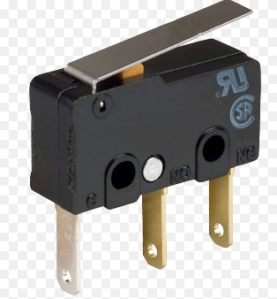

Fig 3.6 Limit Switch

**3.7.2ADVANTAGES**

* Works in almost all environments
* accuracy
* consume little electrical energy
  1. **BUZZER**

SOFT A buzzer or beeper is an audio signalling device, which may be mechanical, electromechanical, or piezoelectric (piezo for short). Typical uses of buzzers and beepers include alarm devices, timers, and confirmation of user input such as a mouse click or keystroke.

**3.8.1BUZZER LAYOUT**

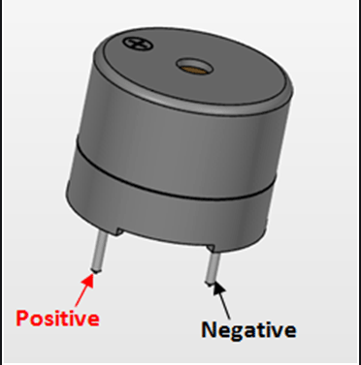

Fig. 3.7 Buzzer

* 1. **SOFTWARE DESIGN**

The different software used to develop the systems is:0

**3.9.1EMBEDDED C LANGUAGE**

Source code is written in C language. Programming in C makes the embedded systems more reliable hence code written for the specific microcontroller can be easily transferred to systems using different microcontrollers. It can be reused, easy to maintain and easy to debug and extend. Also writing in C simplifies code development for large projects. It is easier to modify and update the code.

* + 1. **FLOW CHART**

**START**

**NO**

**YES**

**While 1**

**NO**

**MOTOR ON**

**BUZZER ON**

**YES**

**IF LIMIT SWITCH CLOSE**

**CHECK VIBRATION SENSOR OUTPUT**

**IS EQUAL TO**

**THRESHOLD**

**GSM Initialize**

**Vib = 0**

**MOTOR OFF**

**BUZZER OFF**

**GSM SENDS MESSAGE**

**3.9.3MPLAB IDE FOR SOURCE CODE**

MPLAB Integrated Development Environment (IDE) was used to write the assembly language for 18F452. MPLAB is free software provided by Microchip Technologies Ins. It runs as a 32-bit as well as a 64 bits application on Microsoft Windows and provides a host of free software components for application development and debugging. It can convert the source code into a HEX file, which HEX file is needed before it can be program into the microcontroller. MPLAB IDE also provided a powerful full featured text editor which allows users to create and modify the source code easily. Source code can be debugged easily with the aid of a build results window that displays the bug detected by the compiler when generating the executable files.

**3.9.4EXTREME PIC BURNER FOR BURNING CODE INTO IC**

Extreme Burner PIC is a high quality but low cost port based programmer for the popular PIC18F. This is easy to use programmer with USB connectivity. This programmer supports both ZIF socket and ICSP based programming.

**MAIN FEATURES:**

* In circuit serial programming (ICSP) support.
* Supports all PIC18F- more than 45 devices.
* High Voltage Programming Support.

**3.9.5PROTEUS VSM FOR SIMULATION DESIGN**

Proteus Virtual System Modelling (VSM) is a software that combines mixed mode SPICE circuit simulation, animated components and microprocessor models to facilitate co-simulation of complete microcontroller based designs.

When the coding of microcontroller done writing in MPLAB, HEX file of the source code which is compiled by the MPLAB is load into the Proteus VSM circuit for simulation. Through the simulation, we can straight debug the error in the source code and correct the error immediately. Without this software, we need to burn the HEX file into microcontroller and test or debug error in real circuit. Hence, with Proteus VSM will save a lot time when debugging the error.

**3.9.6SUMMARY**

Thus, this chapter describes about the components selection and the different software used for implementing our system. It briefly describes about the specifications of the components selected and the description about the software used.

**CHAPTER 4**

**ADVANTAGES AND APPLICATION**

**4.1ADVANTAGES**

* Potential reductions of thefts and frauds associated with ATMs.
* Provision to catch the burglar while the police officials reach the location.
* Facility to aware pedestrians about a potential threat through an alarm system.
* Provision to notify the Police officials regarding the situation.
* Time saving methodology.

**4.2APPLICATIONS**

* It is useful in any other applications that require security such as jewellery shops, bank lockers, etc.
* It can be used in every location where an ATM machine has been set up.

**CHAPTER 5**

**CONCLUSION**

**5.1CONCLUSION**

Thus, in order to avoid frauds and related crime cases with ATM we have built a dependable ATM security system with appropriate software programming with the help a PIC microcontroller, a vibration sensor, a gsm module and other peripheral devices. It addresses all the prime issues associated with it such as – SAFETY, TIME CONSTRAINTS, PREVENTION OF THEFT and AID TO THE CRIME FORCE. This embedded system helps to reduce manpower too. We firmly believe that this project or the principle of this project will definitely be useful in different security systems.

**REFERENCES**

1. PIC Microcontroller and Embedded Systems: Using Assembly and C.

For PIC 18 by Muhammad Ali Mazidi, Rolin McKinlay, Danny Causey.

1. PIC Microcontroller: An Introduction to Software and Hardware Interfacing with (CD).

By Han – Way Huang.

1. J. Barwise, J. Etchemendy, The Language of First-Order Logic, Stanford University, 1991.
2. R. Bird, P Wadler, Introduction to Functional Programming, Prentice-Hall, 1988.
3. Embedded Systems: Architecture, Programming and Design.

By – Raj Kamal.

1. Hardware Design SIM900A_HD_V1.01 from SIM Com (A company of SIM Tech).
2. SW – 420 Manual (from – osyteqowebu.cf).
3. P. Fung, T. O'Shea, Learning to reason formally about programs: an observational study of computer science students, 1993.

**APPENDIX**

**BILL OF MATERIALS**

|  |  |  |  |
| --- | --- | --- | --- |
| **Sr. No.** | **Component’s Name** | **Quantity** | **Price (Rs.)** |
| 1 | Pic microcontroller | 1 | 280 |
| 2 | GSM Module (SIM 900A) | 1 | 850 |
| 3 | Vibration Sensor (SW – 420) | 1 | 250 |
| 4 | Capacitor | 2 | 60 |
| 5 | Resister | 4 | 10 |
| 6 | Crystal Oscillator | 2 | 4 |
| 7 | Bridge rectifier | 1 | 10 |
| 8 | IC socket | 1 | 15 |
| 9 | LED | 1 | 2 |
| 10 | Push Button | 1 | 5 |
| 11 | ON/OFF Switch | 1 | 5 |
| 12 | PCB Board | 1 | 500 |
| 13 | Battery | 1 | 50 |
| 14 | L293D | 1 | 100 |
| 15 | Bred Board | 1 | 80 |
| 16 | DC Motor | 1 | 25 |
| 17 | Small Buzzer | 1 | 8 |
| 18 | Push Button | 1 | 2 |
|  | TOTAL | 23 | 2256 |
|  |  |  |  |